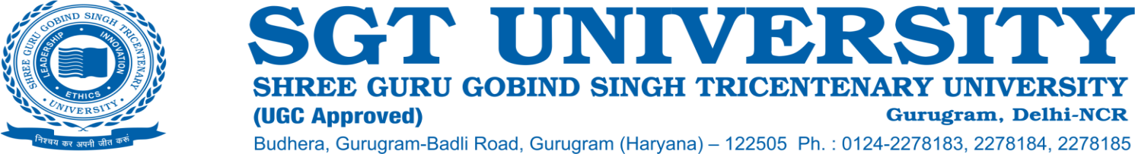

**4.2.2 Describe the adequacy of both outpatients and inpatients in the teaching hospital during the last five years vis-à-vis the number of students trained and programmes offered (based on HIMS/EMR) within 500 words.**

**Response:** SGT University has well-developed health-related faculties including Medical, Dental, Physiotherapy, Allied Health Sciences, Ayurveda, and Yoga & Naturopathy. The University has a state-of-the-art SGT Medical Hospital that caters to the educational needs of students of Medical Sciences, Dental, Physiotherapy, Allied Health Sciences, Nursing, and Ayurveda. The hospital is empanelled under “AYUSHMAN Bharat” and duly registered by the State of Haryana.

**SGT Hospital:** The SGT Hospital provides Casualty and Emergency services with various medical specialty outpatient clinics where teams of experienced clinicians provide complete and compassionate patient care. It is a Multi Speciality Teaching Hospital with 810 operational beds and an average occupancy rate of 89%. The commitment of top management, well-experienced Medical staff, and commitment of the staff are the strength of the hospital. The Institute has well-maintained facilities with the implementation of green initiatives across the Hospital. To date the teaching hospitals, be they Medical, Ayurveda, and Dental, have maintained their standards of teaching as well as patient care and attracted a good number of patients every year.

**Adequacy of Outpatients and Inpatients in the Hospital:** The Medical hospital has more than two lacs OPD footfall every year and an IPD of approx. 25000 which trains more than 900 Medical students. Excellent team of Medical professionals delivers unparalleled medical excellence in multi-specialities comprising Cardiology, Nephrology, Urology, Obstetrics, Gynecology, Mental Health and Behavioral Sciences, GI Surgery, Pulmonology, Critical Care, Neuro Sciences, Orthopaedics, Internal Medicine, Paediatrics, Gastroenterology, Emergency & Trauma, etc.

**Ayurveda Hospital:** The Faculty of Indian Medical system has a separate Ayurveda Hospital with 8 speciality outpatient clinics and 100 bedded inpatient facilities and attracts 250 patients per day for outpatient consultations with training to about 364 undergraduate students. The Faculty of Dental sciences has a separate Hospital with 9 specialities and an OPD of around 60,000 per year and about 200 inpatients are admitted to the Medical hospital for dental surgical procedures. About 586 students have been trained in the last 5 years. Support service includes central kitchen and laundry services and an effective system for biomedical waste management.

**Social Service Initiative of the SGT University:** The University Hospital provides free bus service to patients coming from nearby villages and has adopted 24 villages for providing weekly free medical check-ups and treatment at doorsteps. Under the Govt. of India’s Swa-Prerit Adarsh Gram Yojana (SPAGY) the University has adopted its adjoining Budhera village for its overall development to make the village an educated, healthy, socially harmonious, clean, and hygienic village. The Department of Oral Surgery and Orthodontics have an MOU signed with an International NGO –Smile train and provides funding to free cleft surgery and orthodontic treatment to children affected with cleft lip and palate. The SGT University cleft team is dedicated to providing comprehensive cleft care to these children and their parents.